**Internship Report**

**TECKNIK NEST**

**Week 4**

Muhammad Abdullah (B24F0513SE021)

**BS-SE BLUE (Fall-24)**

**School of Computing Sciences**

**Fachhochschule TECKNIK NEST**

**Internship Dates: 14th June – 31st July 202**

**Task 1:**

Ask user to input any value. Use type() to check its data type. Use exec() to execute a string as Python code.

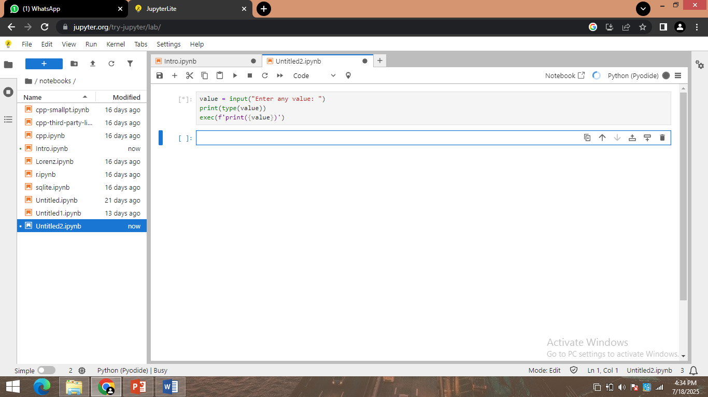

**Task 2:**

Ask user for a Python expression as a string (like '2 + 3 * 4') and evaluate it using exec(). Show result.

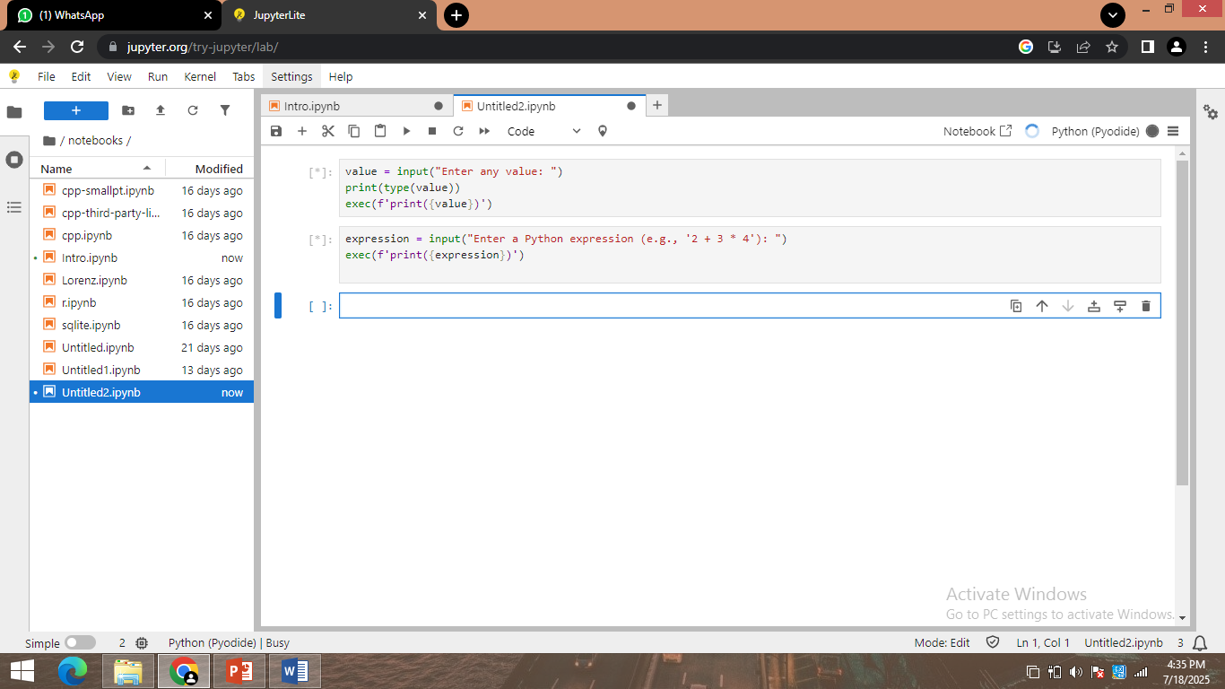

**Task 3:**

Use math module to take a radius input from user and calculate:

- Area of circle, circumference, and square root of area.

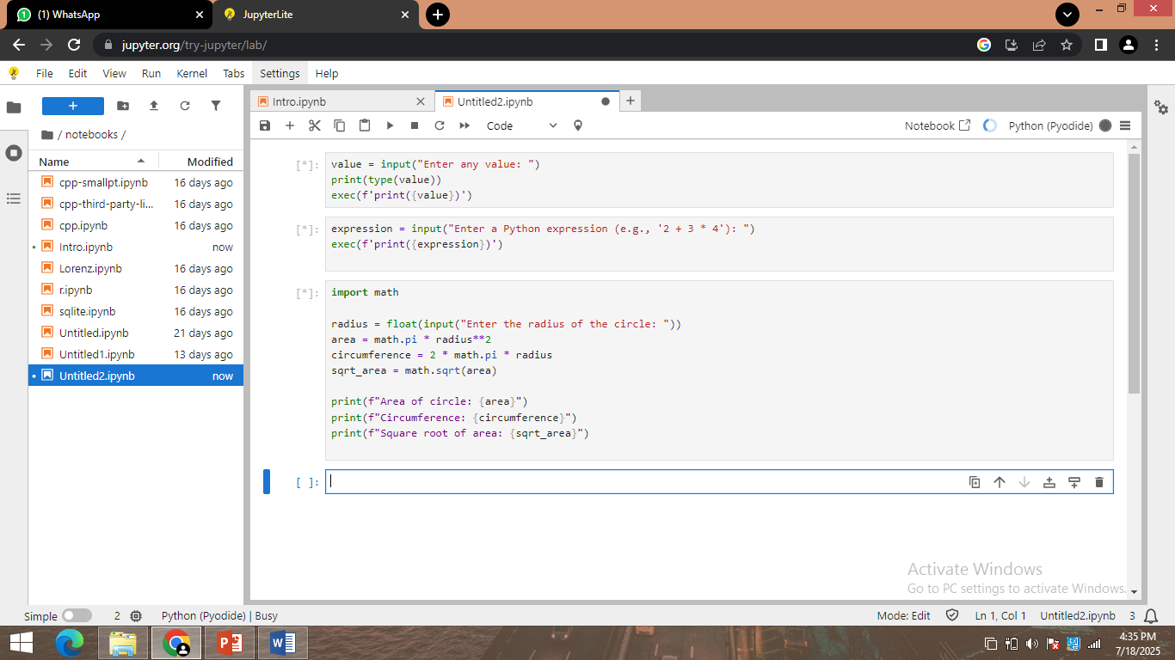

**Task 4:**

Use random module to generate a random 8-character password using letters, numbers, and symbols.

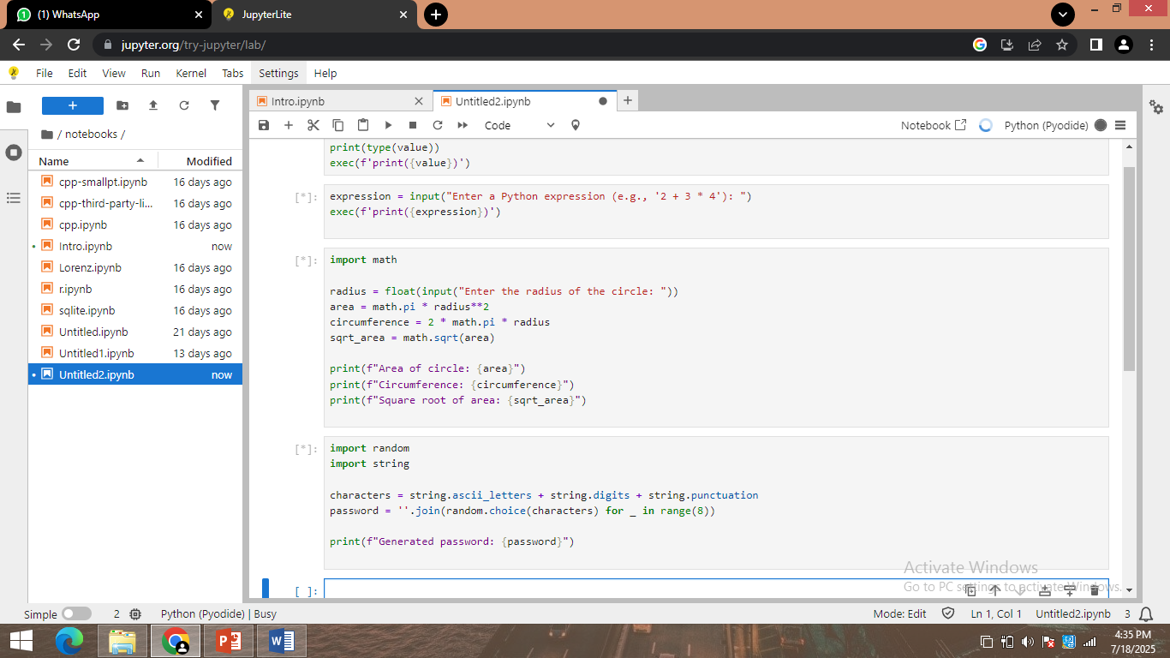

**Task 5:**

Using datetime module, ask user for their birth date and show:

- Their age in years and number of days lived.

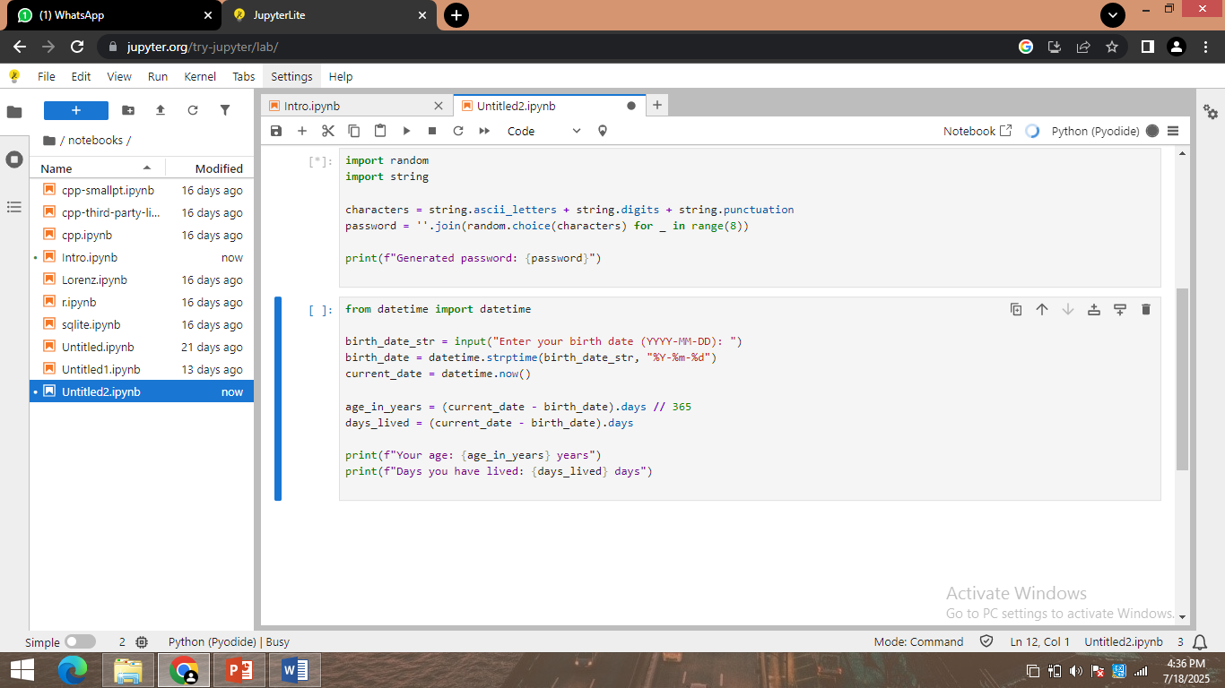

**Task 6:**

Create a script using os and re that lists all `.txt` files from a folder and filters only those that match a pattern (e.g., start with 'report').

